Documentation of the program code

Course Management System

Author: Aleyna AKKAYA

Data: 12/12/2024

# History of technical documentation

**Author**

| Fac. No | Name | E-mail |
| --- | --- | --- |
| 273222036 | Aleyna AKKAYA | [aakkaya@tu-sofia.bg](mailto:aakkaya@tu-sofia.bg) |

**Version history**

| Version | Data | Author | Description |
| --- | --- | --- | --- |
| 1.0 | 10.11.2024 | Aleyna AKKAYA | Discuss with the team and Project manager. Frontend role given to me in the Project. |
| 1.1 | 15.11.2024 | Aleyna AKKAYA | Created a draft of the website to be built, started the Project. |
| 1.2 | 25.11.2024 | Aleyna AKKAYA | Discuss with tester about logins of the students and professors. Tested and solved the issues. |
| 1.3 | 29.11.2024 | Aleyna AKKAYA | Discuss with the Project manager for the |
| 1.4 | 02.12.2024 | Aleyna AKKAYA | Checked for the issues and resolved with tester. |
| 1.5 | 10.12.2024 | Aleyna AKKAYA | Speak with the Project manager for the last touch of the page. |

# 

# Content

1 Introduction 4

2 Detailed design 4

2.1 Class diagramm 4

2.2 Sequence diagram 5

2.3 Sample user interface 6

3 Testing 6

# Introduction

I worked as a Frontend Developer to build a course management website using HTML. The site helps manage online courses by making it easy for administrators to add and update course details, track students, and navigate the platform smoothly. I focused on creating a simple and clean design that makes it easy for users to interact with the site. This project shows my ability to build functional and easy-to-use websites while making sure they look good and are easy to navigate.

# Detailed design

## Class diagram

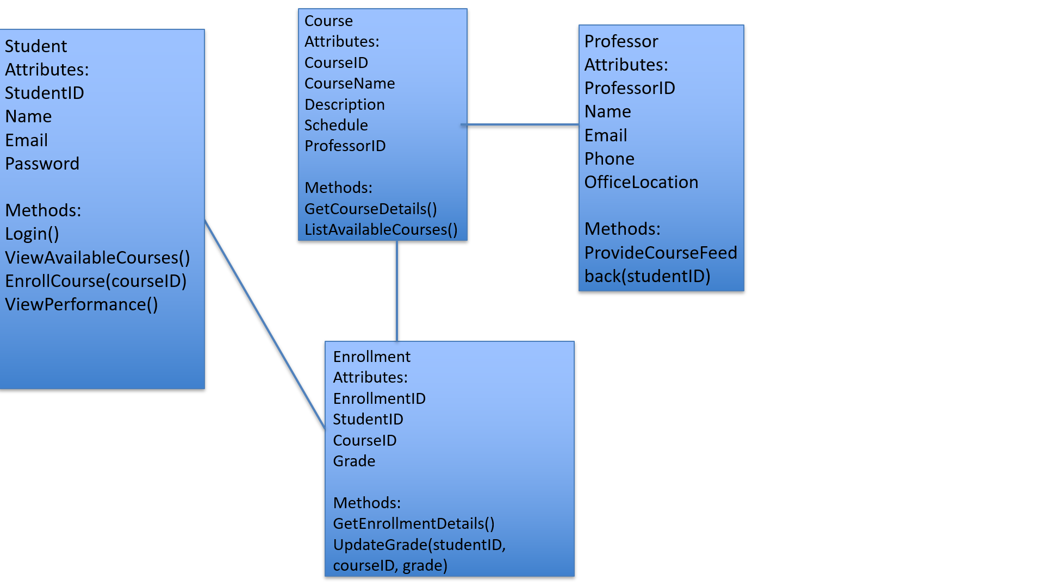

## Sequence diagram

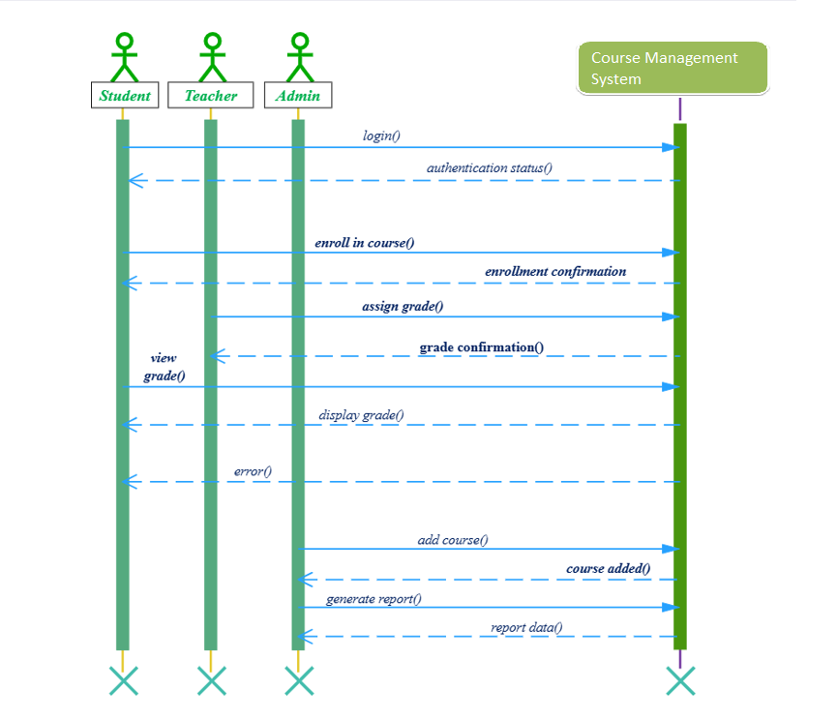

## Sample User interface

metin, ekran görüntüsü, yazı tipi, logo içeren bir resim

Açıklama otomatik olarak oluşturuldu

# Testing

1. Broken Image Links

Issue: Images are not displayed because the file paths are incorrect.

Solution: Verify that the file paths in the src attribute are accurate and always include an alt attribute for accessibility

Example of the code:

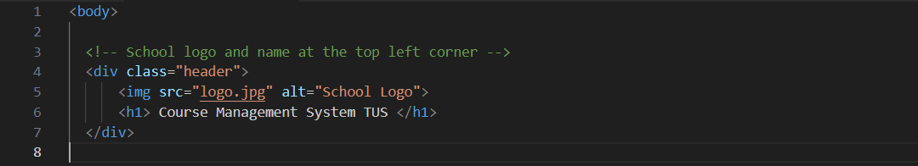

1. **Form Redirects to the Wrong Page**

***Issue:*** *After submitting the form, the user is redirected to the wrong page.*

***Solution:*** *Make sure the action attribute of the form is pointing to the correct URL.*

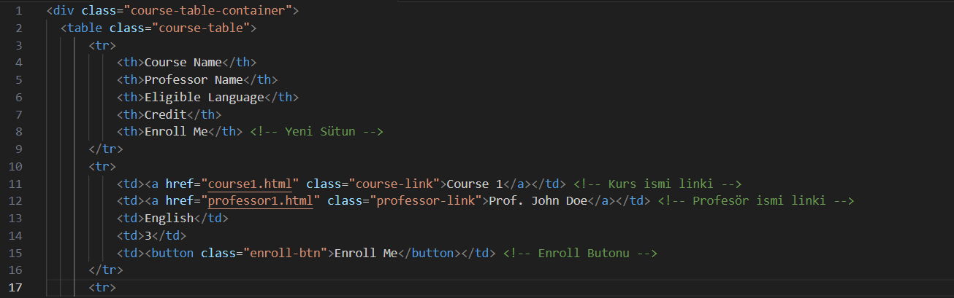

1. **JavaScript Errors**

**Issue:** JavaScript functionalities (e.g., form validation) fail due to syntax errors or incorrect file paths.

**Solution:** Check the browser console for errors and verify the script file is correctly linked.

